**NOISY FRIDAY: Noisy Friday** will be all about experimental and loud music—from punk to metal—featuring some of our favorite acts from Luxembourg and the Greater Region. Fans of heavy music will get to experience the political energy of Carmen Colère (FR), the powerful riffs of Luxembourg’s metal legends Scarred and Sublind, the raw punk sound of Noise Church, and cap off the night with the high-octane speed metal of Perkölatör (BE).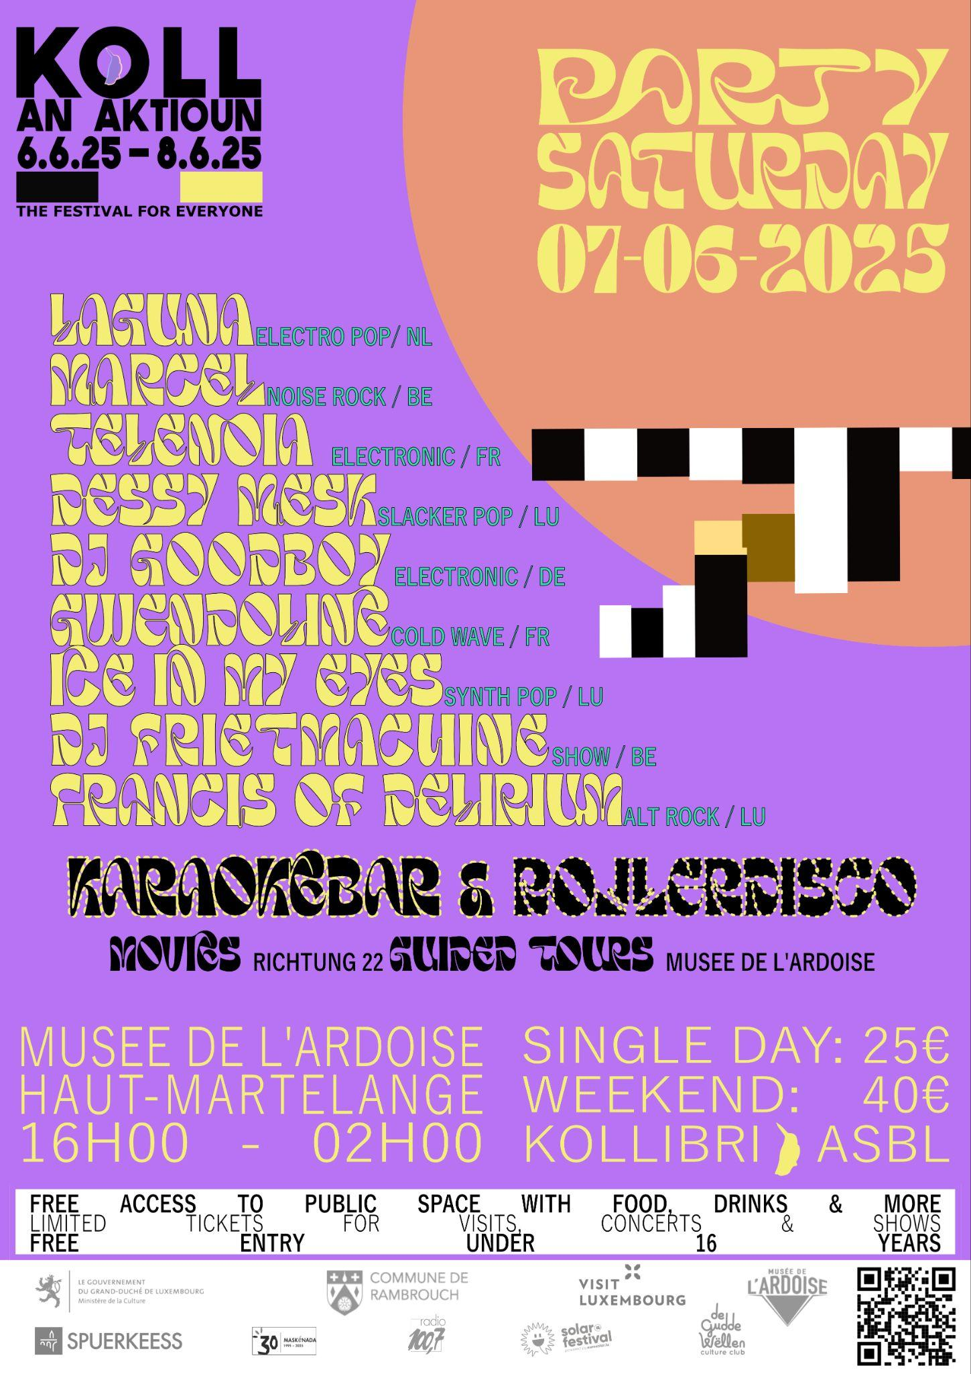

**PARTY SATURDAY 07.06.2025  
DESSY MESK |**Dessy Mesk has carved out a unique sound in Luxembourg's music scene. Their catchy beats and cheeky storytelling, exploring themes of love and heartbreak, ensure an engaging experience from start to finish.

**LAGUNA |** Laguna captivates with her crystalline voice and trance-inducing dark electronic pop. Her debut EP, *Drifting*, was written and produced with an all-female team, exploring her search for deep connections.

**ICE IN MY EYES |** Combining 80's sounds with infectious energy, Ice in My Eyes creates a danceable atmosphere. Based in Luxembourg, their latest album *New Romantic* continues their signature pop-driven sound with catchy hooks.

**FRANCIS OF DELIRIUM |** Created by solo artist Jana Bahrich, Francis of Delirium blends grunge and folk into high-energy indie rock. Their evocative sound encourages introspection through their emotionally raw music. Definitely a highlight of the local music scene getting accolades from music journalists worldwide.

**GWENDOLINE |** Gwendoline, a duo from Rennes, creates cold-wave, dark yet poetic music. Their shlag wave style is influenced by everyday conversations and themes of fatalism, self-deprecation, and societal disillusionment. A must see at Koll 2025!

**MARCEL |**  Marcel’s music is an indie/post-punk carnival of noise, blending playful chaos with powerful messages, exploring sabotaging civilization and the mysteries of the collective unconscious. After ESNS 2025, the band from Arlon brings their energy to Koll!

**TELENOIA |** Telenoia, by Clement Leveau (Jumo) and Sylvain Pelier (Maze), creates hypnotic electronic tracks perfect for late-night festival raves, blending deep beats with trancelike energy.

**DJ GOODBOY |** Berlin-based DJ, producer, and drummer Pascal Karier, known as DJ Goodboy, brings kaleidoscopic dance sets that combine energetic grooves, ambient vocals, and unpredictable rhythms for a dynamic crowd experience.

**FAMILY SUNDAY 08.06.2025**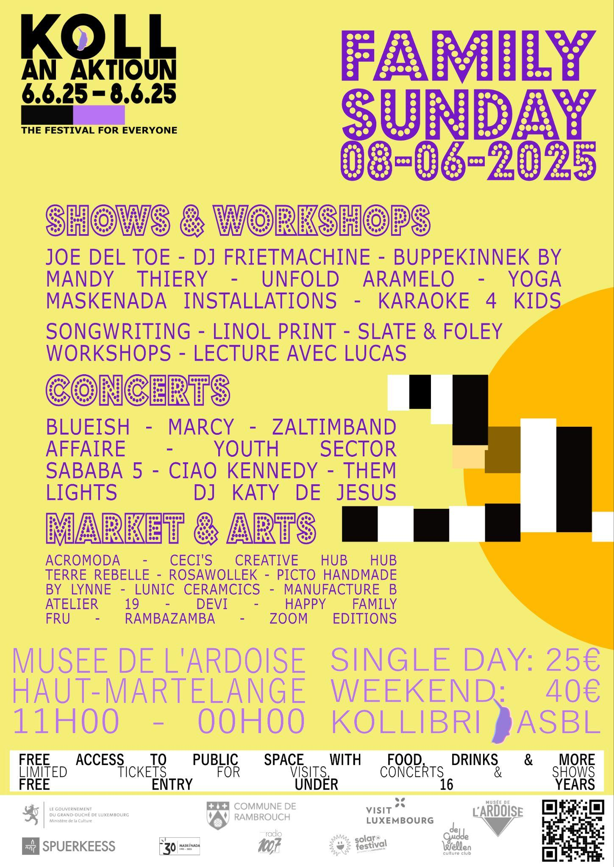

**BLUE-ISH |**Blue-ish, a Luxembourg singer-songwriter, crafts indie pop folk songs about life’s messiness. Her authentic and raw performances explore love and personal experiences, with a touch of vulnerability and strength.

**MARCY |** Marcy, a Luxembourg-based artist, fuses alternative pop-rock with introspective lyrics. After her debut EP in 2022, she’s building a promising career with energetic live shows and an upcoming studio album.

**ZALTIMBAND |** Zaltimband, the family of musicians from the Zaltimbanq circus school, brings joyful Klezmer music that invites the crowd to dance and enjoy the lively energy of the afternoon.

**AFFAIRE |** Affaire merges electronic beats with rock, inspired by David Byrne and Alan Vega. Their pulsating rhythms and twitchy guitars create an offbeat groove that’s both unusual and danceable.

**YOUTH SECTOR |** Brighton’s Youth Sector offers high-energy indie music with a sense of catharsis. Their upbeat sound, influenced by DEVO and Talking Heads, brings positivity and catchy choruses to their electric live performances.

**SABABA 5 |**Sababa 5 embarks on a new journey with their album *Nadir*, blending psychedelic soul and Middle Eastern grooves into a hypnotic, cinematic sound that connects past and future influences.

**CIAO KENNEDY |** Ciao Kennedy mixes modernity with nostalgia, creating electric, colorful music that blends jazz, post-rock, and electronic elements. Their debut EP marked the start of their bold instrumental journey.

**THEM LIGHTS |** Sacha Hanlet’s *THEM LIGHTS* transcends genres, blending Blade Runner-esque arpeggios, dark electronica, and mainstream sensibilities, offering a fresh sound beyond his work with MUTINY ON THE BOUNTY.

**KATY DE JESUS|** Katy De Jesus combines her Portuguese roots with Luxembourgish upbringing and Berlin’s underground vibe. Known for her dynamic dance sets, she brings a captivating mix of 80’s/90’s house and high-energy rhythms.

**SPOTIFY PLAYLIST:**

https://open.spotify.com/playlist/6MTSLANZx9aIwKwHd8zXNe?si=9907858873c74696